**SKEWNESS, KURTOSIS**

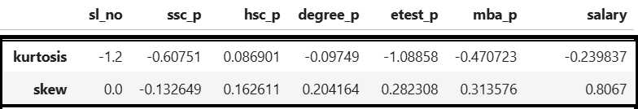

|  |
| --- |
| Dataset considered: Placement Dataset |

**Points to know from the table:**

* Each column in the placement dataset explains the varied range of skewness and kurtosis and the explanation can be done as reference.

**SKEWNESS:**

* All variables show low skewness, suggesting that their distributions are approximately symmetric.
* Slight positive skewness is observed in hsc_p (0.16), degree_p (0.20), etest_p (0.28), mba_p (0.31), and salary (0.80), indicating a mild right-skewness, especially for salary.
* ssc_p shows a slight negative skewness (-0.13), indicating a mild left-skewness.
* sl_no has a skewness of 0, indicating a perfectly symmetric distribution.

KURTOSIS:

* Most variables have negative kurtosis (e.g., sl_no = -1.2, ssc_p = -0.60, degree_p = -0.09, etest_p = -1.08, mba_p = -0.47, salary = -0.23), suggesting flatter (platykurtic) distributions than normal.
* Only hsc_p has a kurtosis close to zero (0.08), indicating a distribution close to normal.